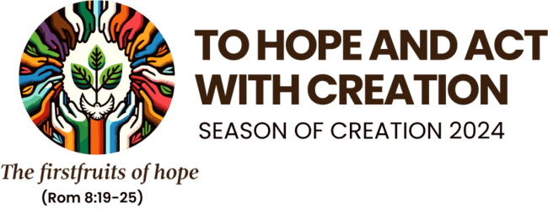**The Season of Creation is a time to renew our relationship with our Creator and all of creation through celebration, conversion, and commitment together. The season starts on 1 September, the World Day of Prayer for Creation, and ends 4 October, the Feast of St. Francis of Assisi, the patron saint of ecology beloved by many Christian denominations. During the Season of Creation, we join our sisters and brothers in the ecumenical family in prayer and action as the world’s 2.2 billion Christians come together to care for our common home. Creation is not given to humanity to use and abuse, rather, humanity is created to be part of Creation and to care for it.**

**This year’s theme for Season of Creation is “To Hope and Act with Creation”; taking the inspiration from the letter of St Paul to the Romans in chapter 8, “Creation is groaning”. Creation is, in our present time, groaning because of the unsustainable actions that harm her: global warming: extreme weather events, damaging gas emissions into the atmosphere, the destruction of biodiversity in earth and seas. And those who suffer most are the poorest of the Earth. Consequently, we are called to hear the cry of the earth and the cry of the poor. We are also called to hope through action for a more sustainable world.**

**We are delighted to share with you an extensive set of resources, provided by the Laudato Si’ Working Group of the Irish Bishop’s Conference and Trócaire, which we hope you will share with your local parish council, liturgy groups or care for creation group. All these resources are available by going to https://www.trocaire.org/our-work/working-in-ireland/parishes/.**

**There is also a ‘Care for Our Common Home’ page on the Irish Bishops’ Conference website which contains the resources for the Season of Creation as well as the “Return to Nature” section for parishes who wish to ‘go wild’ and join the call to return 30% of Church grounds to nature and much more. You can find them by going to https://www.catholicbishops.ie/laudato-si/.**

**You might also like to join us and promote this Season of Creation Lecture: "Developing an Eco-Spirituality - To Hope and Act with Creation" on 19th September at 7.30pm in Renehan Hall, St. Patrick’s College Maynooth. Xavier de Bénazé SJ will explore eco-spirituality and Laudato Si’ through different perspectives which reflect on the current environmental crises and how eco-spirituality is part of the solution. To register for this event please email cmurphy@jcfj.ie**

**On behalf of Trócaire, wishing you all of God’s blessings for a beautiful Season of Creation.**

**“Truly, much can be done!” (Laudato Si’, 180)**

**With thanks, Trócaire Church team**

**"The Cry of the Earth - the Cry of the Poor"**

**If you feel you would like to make a concrete response to your prayer - “Loving and Creator God, we pray that you will make us sensitive to these groans and enable us to have the same compassion as that of Jesus, the redeeming Lord” – You might like to make a donation to Trocaire for those places suffering the most from ecological injustices.**